**Setting up Windows**

Installing Windows 10 steps, was unable to install windows 11, because my machine is does not meet the minimum system requirements to run windows 11.Here are the steps I used to install windows 10,

1. Check System Requirements

Ensure your PC meets these requirements:

Processor: 1 GHz or faster, 2+ cores

RAM: 4 GB

Storage: 64 GB

TPM: version 2.0

UEFI, Secure Boot capable

DirectX 12 compatible graphics

2. Backup Your Data

Backup important files to an external drive or cloud storage.

3. Create Bootable USB Drive

Download the Media Creation Tool from the Microsoft website.

Run the tool to create a bootable USB drive.

4. Install Windows 11

Insert the bootable USB drive.

Restart your PC and enter BIOS/UEFI (usually by pressing F2, F12, Delete, or Esc).

Set USB as the boot device and restart.

Follow the installation prompts:

Select language, time, and keyboard.

Click "Install Now."

Enter your product key (or skip if you don’t have one).

Accept license terms.

Choose "Custom: Install Windows only (advanced)."

Select the partition to install Windows 11 and click "Next."

5. Complete Installation

Follow on-screen instructions to set up preferences.

Install device drivers and check for Windows updates.

6. Restore Your Data

Copy your backed-up data to the new Windows 11 installation.

I am currently on windows 10

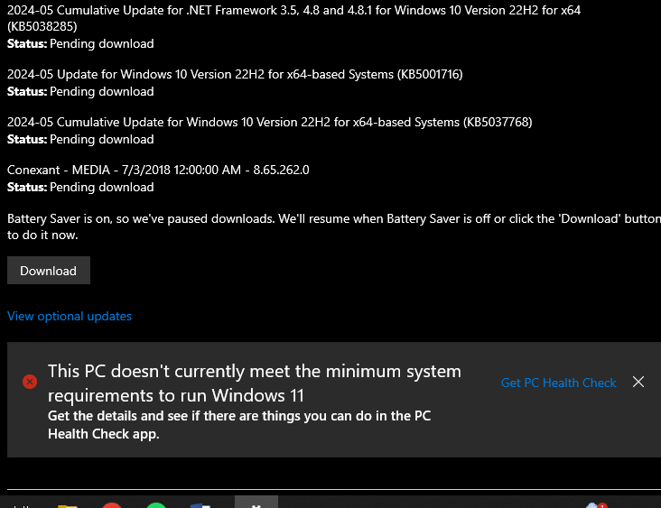

**Steps for installing Visual Studio Code**

Used the link provided which directed on the official page for downloading visual studio.

Run Installer: Double-click the downloaded file.

Setup: Follow the prompts, accepting the license and choosing installation options.

Finish: Click "Finish" to complete the installation.

Here is how it looks after the download ,

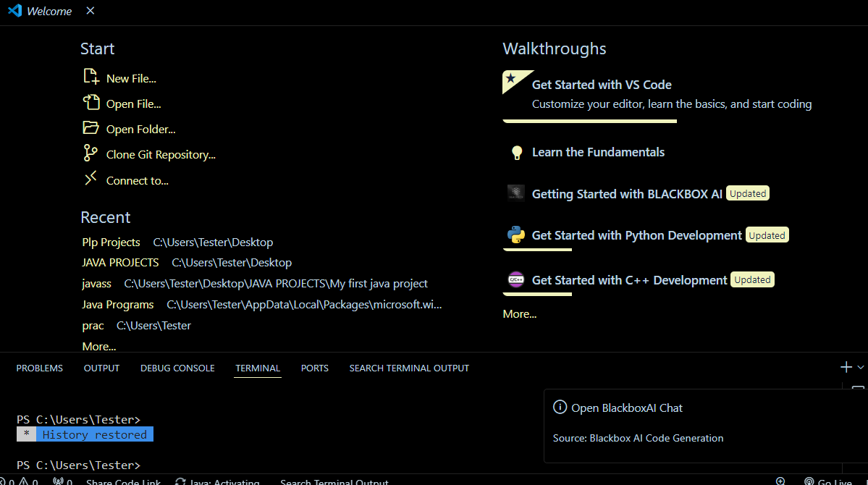

**Setting up GIT**

Download: Go to git-scm.com and download the Windows installer.

Run Installer: Double-click the downloaded file.

Setup: Follow the prompts, choosing default options unless you have specific preferences.

Finish: Click "Finish" to complete the installation.

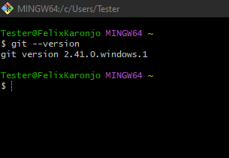

Link to my GitHub account

<https://github.com/karonjo2>

Link to repository

<https://github.com/Powerlearnproject/se-assignment-1-setting-up-your-developer-environment-karonjo2>

Setting up Python

Download: Go to python.org and download the installer.

Install:

Windows: Run the installer, check "Add Python to PATH", and click "Install Now".

Since I already have an IDE (Visual Studio Code)

Open VS Code.

Install Python Extension:

Press Ctrl+Shift+X (or Cmd+Shift+X on macOS), search for "Python", and install the extension by Microsoft.

Select Interpreter:

Press Ctrl+Shift+P (or Cmd+Shift+P), type "Python: Select Interpreter", and choose your Python installation.

Run Code:

Open a .py file and press F5 to run it.

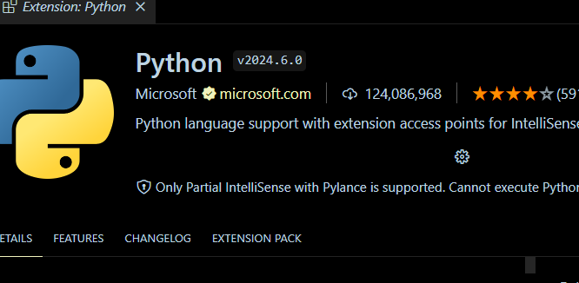

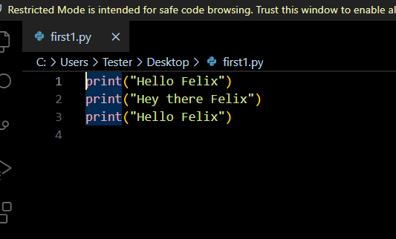

**Setting up Pip**

1. Verify Python Installation:

Open command prompt and type the following commands

pip –version

1. Install pip:

Open Command Prompt and download the get-pip.py script:

curl https://bootstrap.pypa.io/get-pip.py -o get-pip.py

1. Run the script:

python get-pip.py

1. Verify the installation:

pip --version

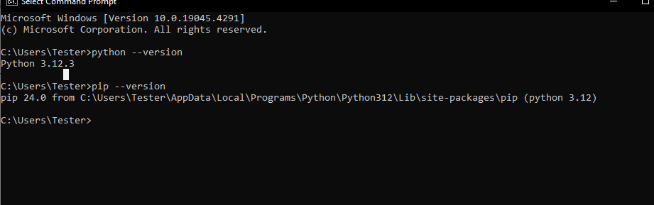

**Setting up MySQL**

1. I followed the link provided on the gitihub

<https://dev.mysql.com/downloads/windows/installer/5.7.html>

1. Install MySQL

Run the Installer:

Double-click the downloaded file to start the installation.

Choose Setup Type:

Select "Developer Default" or another option based on your needs.

Install Dependencies:

Allow the installer to download and install any required software.

1. Configure MySQL Server

Configuration:

Follow the prompts for "Standalone MySQL Server."

Type and Networking:

Select "Development Machine" and ensure "TCP/IP" is checked.

Authentication Method:

Choose "Use Strong Password Encryption."

Accounts and Roles:

Set a root password and create additional user accounts if needed.

Windows Service:

Opt to run MySQL as a Windows Service.

Apply Configuration:

Click "Execute" to apply settings.

1. Complete Installation

Finish:

Complete the installation and configuration process.

Verify Installation:

Open "MySQL Command Line Client" and log in with the root password.

Run SHOW DATABASES; to verify.

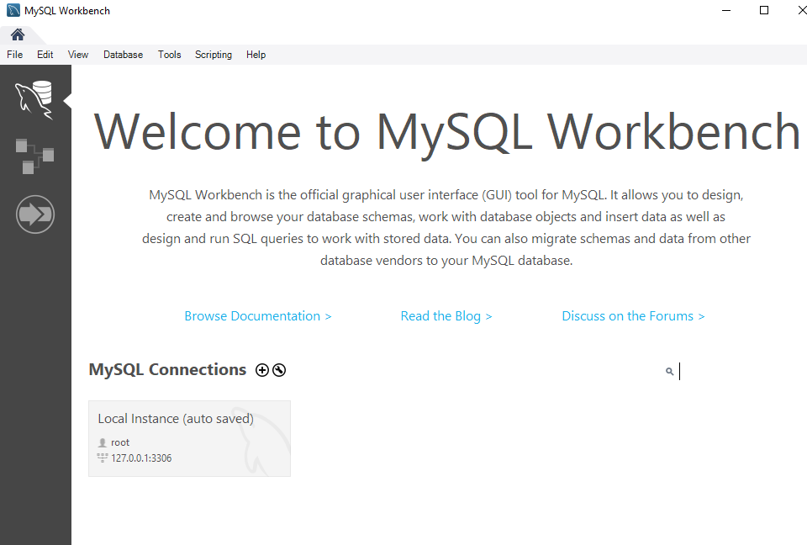

**Explore Extensions and Plugin**

For installing extensions I went opened my vs code and navigated to the extensions icon



Here are some of the extensions downloaded on Visual Studio Code

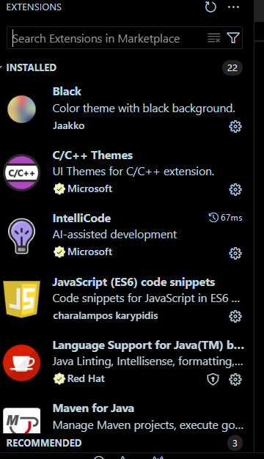

**Challenges faced while setting up the above environments**

Network Connectivity: Users with unstable or slow internet connections may experience difficulties downloading the installer or extensions. This can lead to incomplete installations or timeouts during the installation process. I went somewhere with stable internet connectivity.

The interpreter for python was not working hence I had to configure it myself and seek assistance from resources such as YouTube which actually helped in the configuration

Working with the command line was a bit hectic because I have minimal knowledge about it used chatgpt for help with some of the commands.

MySQL was not compatible with the current version of my os , hence I had to upgrade it to windows 10

Website Accessibility: MySQL can be downloaded from the official MySQL website or through package managers. Occasionally, the website may experience downtime or slow loading times due to high traffic, which can impede the download process. I had to use a stable internet connectivity.